**Texas Tech University**

**Department of Computer Science**

**Course:** Introduction to Artificial Intelligence **Group:** 1

**Instructor:** Dr. Juan Carlos Rojas **Email:** [Juan-Carlos.Rojas@ttu.edu](mailto:Juan-Carlos.Rojas@ttu.edu)

**Hours:** 8:00 – 12:00 (Saturdays) **Room:** 320

# Homework 1

Due Saturday, May 25 at 8:00am.

## Practice 1

Create a Python program that:

* Creates a list *x* with values between 0 and 100
* Creates a list *y* with values derived from x like this:

*y[i] = x[i] * 3 + 5*

* Prints *y*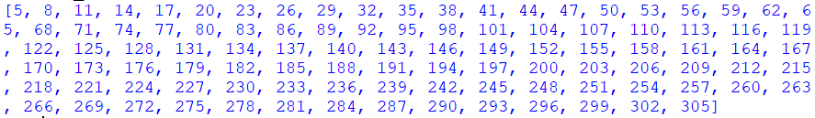

## Practice 2

1. Create a Python program that plots the function y = 3x + 5, for a range of values of x in   
   [-10, +10].
2. Repeat part a), but his time add a random value of +/-5 to each value of y. Plot the values in an x-y plot (a scatter plot).
3. Combine a) and b) to plot the scatter plot with the trend line on top.

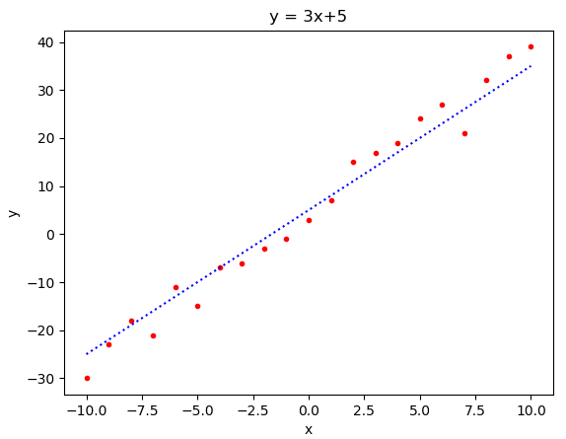

## Practice 3

* Create a 3x3 matrix with the following values: $x=\left[\begin{matrix}1 & 2 & 3 \\ 3 & 1 & 2 \\ 2 & 3 & 1\end{matrix}\right]$
* Compute the inverse *y=x-1*
* Mutiply *y*x* and show that the result is the identity matrix

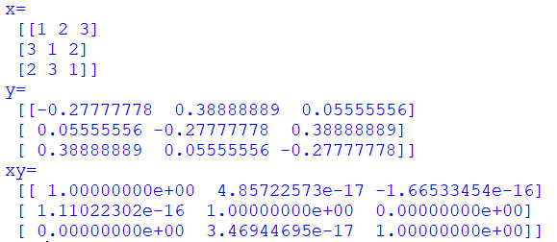

## Practice 4

* Read the periodic table CSV file (PeriodicTable.csv) into a Pandas dataframe
* Create a column that computes the ratio between the atomic mass and the atomic number

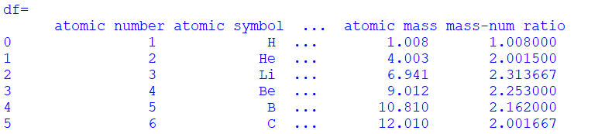

## Practice 5

* Read the vehicle price dataset (craigslistVehicles.csv) into a Pandas dataframe
* Plot a histogram of each of the numeric variables (year, odometer, price) using 50 bins

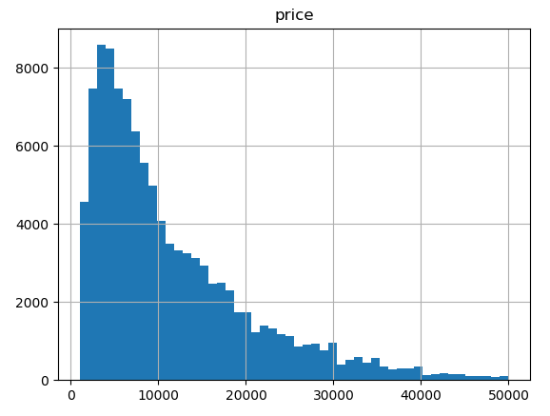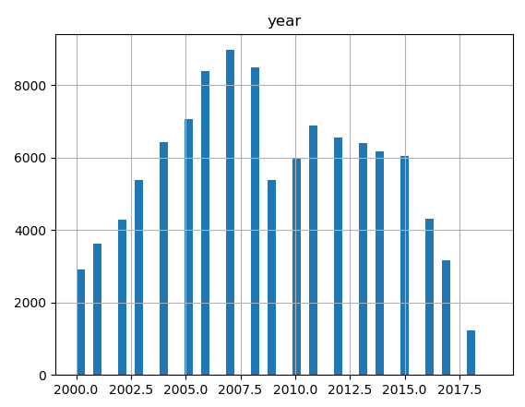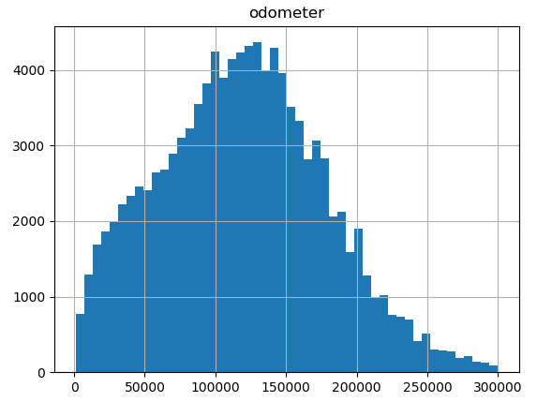

## Practice 6

* Read the vehicle price dataset (craigslistVehicles.csv) into a Pandas dataframe
* Plot a scatterplot of price vs. year
* Plot a scatterplot of price vs. odometer

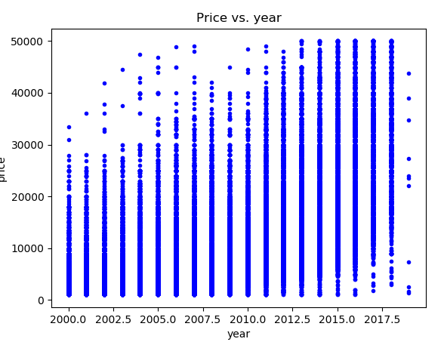 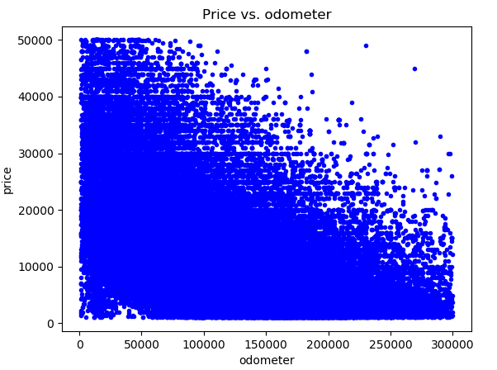

## Practice 7

* Solve the Normal Equations to compute a linear-fit model for price vs. odometer of the form: *y = m*x + b*, where *x* is the vector of odometer values, and *y* is the vector of prices.
  + *m* should be a single coefficient
  + *b* should be a single value for the intersection
* Plot the scatterplot of price vs. odometer, with the best fit trendline on top

